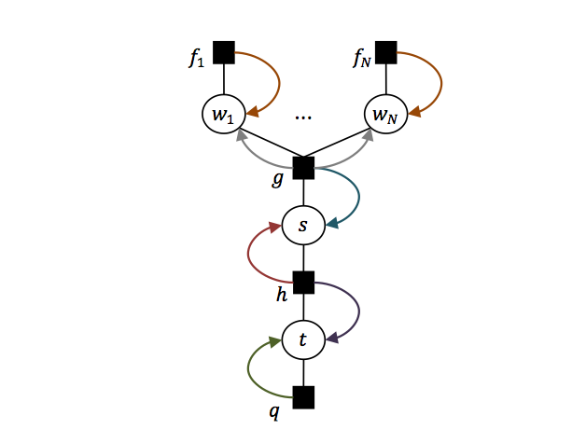

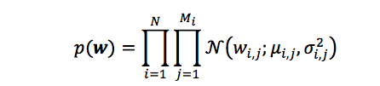

Macintosh HD:Users:yangchao:Desktop:Screen Shot 2015-03-04 at 11.40.03 AM.png

Macintosh HD:Users:yangchao:Desktop:Screen Shot 2015-03-04 at 11.40.15 AM.png

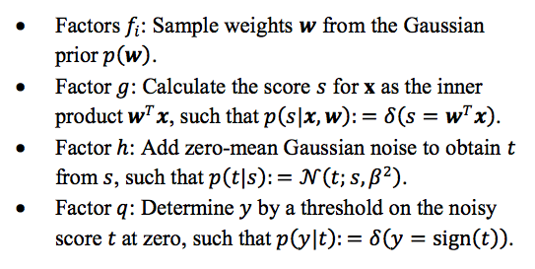

Macintosh HD:Users:yangchao:Desktop:ExpectationPropagationThesis:Adpredictor_Related_articles:sumVariance.png

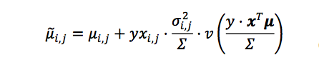

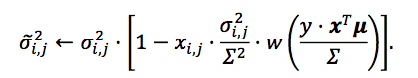

Theory Background：



minimize KL-divergence subject to the constraint that is a Gaussian distribution.



in others words, expectation constraints:

















Rank 1 updates:







logistic function:

When 

Approximation:

 are the nodes and weights for integration against .







(Those formulars directly copied from Tom Minka’s EP notes.

I personally doubt its correctness.)

(About above equations, please consult numerical recipes)

(numerical-recipes:











, , 

Updates:

For rank1 updates, simplify further



 in which 

 in which 